**How to use morgan npm package ?**

Code:

let express=require("express")

let morgan =require("morgan")

let app=express()

let port=3000

app.use(morgan("dev"))

app.get("/user",(req,res)=>{

    res.send("this is getting information")

})

app.post("/user",(req,res)=>{

    res.status(202).send("this is post requiest")

})

app.listen(port,()=>{

    console.log(`your server is running at http://localhost:${port}`)

})

**When we do a get request in browser ?**

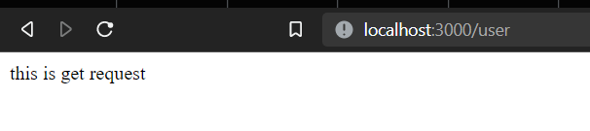

We can see in the terminal that happens :

